**Task 2:**

**With the appropriate database management system (DBMS), create a cloud database system for the Medicare Health System according to the data relationship diagram (ERD) that you set up using SQL DDL.**

**SQL Server:**

Doctor, Patient:

Appointment:

Equipment:

Facility:

Define and create a simple interface for inserting, updating, and deleting data in the database using an appropriate development environment (Visual Studio) to create and provide the solution with screenshots. You also have to implement the verification methods specified in the cloud database system professional scenario within your interface

**Visual Studio:**

**Patient:**

Insert:

Update:

Delete:

Constraints:

**I will try to fill an exists ID**

**I will try to fill an exists Email**

**Run and retrieve useful information by executing SQL queries (Select, Group by, Between, Where, Order by, Join) on the Medicare Health database system applied.**

**SELECT.**

**Retrieve all columns for all patients**

**Group by.**

**Statistics of the number of patients per city**

**Between**

**Retrieve patients with an ID between 1 and 3**

**Where.**

**Recovery of patients of a specific sex**

**Order by.**

**Retrieve patients sorted by date of birth in descending order**

**Join.**

Retrieve patient details along with associated equipment information

**You must deploy a Medicare Health System relational cloud database system using an appropriate method and tool (AWS).**

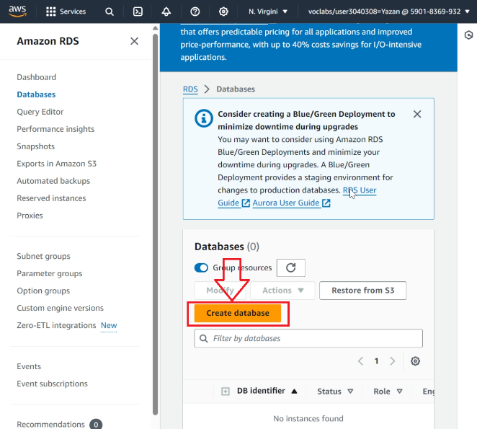

**Perform and explain how security mechanisms were used and the importance of these mechanisms for the security of the Medicare Health System cloud database system. In addition, implement a strong and appropriate security password in the cloud database system you have developed. You should also back up your data, by presenting your work with screenshots and explaining how you did it.**

**1. AWS Security Measures:**

**When creating a secure environment for the Medicare Health database on AWS, a robust set of security measures was implemented.**

Virtual Private Cloud (VPC): The database resides within the finely configured AWS Virtual Private Cloud (VPC). This strategic decision ensures that the database is protected within a private network, limiting access to it exclusively on authorized entities. VPC setup acts as a secure area, protecting sensitive healthcare data from unauthorized access.

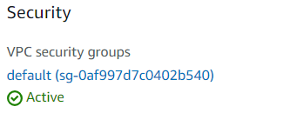

2. Database Security:

Securing the Medicare Health SQL Server database includes a multifaceted approach, ensuring the confidentiality and integrity of healthcare records.

**SQL Server authentication: Implementing** a SQL Server authentication mode strengthens database defenses. Strong and complex passwords are mandatory for all database logins, adding an extra layer of protection against unauthorized access. This strict authentication mechanism ensures that only authenticated users with the right credentials can access the database.



**3. Strong password system:**

Ensuring the integrity of user credentials is critical to maintaining the overall security posture of the Medicare Health database. A robust password system has been implemented accurately.

**SQL SERVER PASSWORD**

**AWS PASSWORD**

**4. Backup data in Microsoft SQL Server:**

**Manual backup:**

Manual backups are performed by using SQL Server Management Studio (SSMS).

Full and differential backups and transaction history are taken on a regular basis.

Backups are stored in a secure place, separate from the production database server.

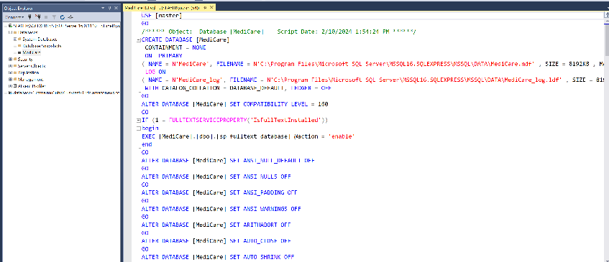

**AWS Automated Backup:**

Automatic AWS RDS backups are leveraged for timely recovery.

The retention period is configured based on data recovery requirements.

Backup encryption is enabled to enhance security.

**The performance of your cloud database system is important. Therefore, you should identify and investigate the measurements and performance of your cloud database system ( Medicare Health System) based on the previous solution and the work you have provided regarding response and access lag. Provide a solution with screenshots and explain how you applied it to your system.**

- We may consider BurstBalance, CPUCreditBalance, CPUCreditUsage, CPUtilization, latency, and accessibility metrics while evaluating the performance of the MediCare cloud database system . Here is a breakdown of each action and how it relates to the effectiveness of the system:

**Explanation in general about all metrics:**

**1. Latency Analysis:**

**أ. BurstBalance:**

The BurstBalance graph measures the bursible performance balances available for Amazon EBS volumes. Balanced and adequate BurstBalance ensures consistent I/O performance, avoiding bottlenecks.

**ب. CPUCreditBalance وCPUCreditUsage:**

CPUCreditBalance and CPUCreditUsage monitoring provides insights into CPU credit usage. Maintaining a healthy balance is critical to avoid exhausting CPU balance, which can affect performance during burst workloads

**ج. CPUSurplusCreditBalance وCPUSurplusCreditsCharged:**

These metrics reveal surplus available and consumed CPU balances, respectively. Surplus CPU balances refers to the efficient use of resources, while careful monitoring of charged balances ensures cost-effective operation.

**d. CPU usage:**

CPUUtilization usage is a key indicator of the overall CPU performance. Consistent monitoring helps identify patterns and potential spikes, and guides optimization efforts for resource allocation.

**2. Accessibility analysis:**

**A. Database Connections:**

The DatabaseConnections graph evaluates the number of database connections over time. Steady and manageable growth in communications ensures that the database can effectively handle user demand without compromising accessibility.

**ب. DBLoad وDBLoadCPU:**

DLoad and DBLoadCPU metrics provide an understanding of database load and associated CPU usage. Balancing these loads is critical to ensuring responsive query processing and maintaining the optimal user experience.

**c. Disk queue depth:**

DiskQueueDepth monitoring detects the number of I/O operations pending on the disk. Consistent, low queue depth indicates efficient disk performance, reducing latency in data retrieval and storage.

**Application:**

EBSByteBalance% measures the balance of bytes read and written to Amazon EBS volumes. Balanced byte distribution ensures that I/O operations are distributed evenly, preventing potential bottlenecks.

**3. Measurements and improvements:**

Baseline of performance:

A baseline for each scale during normal operating conditions to identify deviations during peak periods.

**Scaling resources:**

Expand resources based on observed trends. Increase CPU capacity during periods of high CPU usage.

**Workload distribution:**

Distribute read and write operations to keep EBSByteBalance balanced, preventing overuse of specific storage resources.

**Connection pooling:**

Communication aggregation strategies to efficiently manage database connections, prevent resource depletion and improve overall database accessibility.

**Query optimization:**

Analyze and optimize frequently executed queries to reduce DBLload and associated CPU usage , ensuring efficient data retrieval.

**Monitoring Alerts:**

CloudWatch alerts to receive notifications about abnormal patterns in metrics, allowing for proactive intervention and troubleshooting.

**Now the metrics of MediCare's own database will be explained:**

**1. BurstBalance:**

Looking at the BurstBalance chart, it is clear that the system maintains a stable and healthy credit balance of performance. This ensures that Amazon EBS volumes have sufficient resources to handle extreme workloads without compromising I/O performance.

**2. CPUCreditBalance وCPUCreditUsage:**

In the CPUCreditBalance graph, we see a strong balance, indicating that the system has sufficient inventory of available CPU credits. At the same time, the CPUCreditUsage graph shows controlled consumption, ensuring optimal use of resources without exhausting available credits.

**3. CPUSurplusCreditBalance وCPUSurplusCreditsCharged:**

The CPUSurplusCreditBalance chart reveals a useful surplus in CPU balances, indicating efficient resource management during diverse workloads. At the same time, CPUSurplusCreditsCharged reflects prudent usage, preventing unnecessary charges.

**4. CPUUtilization:**

By examining the CPUUtilization graph, we can observe the overall performance of the CPU. Sustainable or high CPU usage may indicate the need to proactively scale resources to maintain responsiveness during periods of increased demand.

**5. DatabaseConnections:**

The DatabaseConnections graph visually represents the number of database connections over time. A steady and gradual increase is essential, ensuring that the database can effectively manage user demand without experiencing connectivity bottlenecks.

**6. DBLoad وDBLoadCPU:**

The DLoad and DBLoadCPU metrics on the graphs provide insights into database loading and associated CPU usage. Balanced loading and efficient CPU utilization are critical to processing responsive queries, contributing to an optimal user experience.

**7. DiskQueueDepth:**

The DiskQueueDepth graph provides visibility of distinct disk I/O operations. Consistent, low queue depth indicates efficient disk performance, reducing potential bottlenecks in data recovery and storage.

**8. EBSByteBalance %:**

By focusing on the EBSByteBalance graph, we see the balance of read and written bytes in EBS volumes. A well-distributed byte balance is critical, ensuring even I/O operations and preventing overuse of specific storage resources.

**This comprehensive analysis allows us to measure the health and efficiency of a cloud database system. It is essential to maintain balance, prevent resource depletion, and proactively scale resources based on observed trends to ensure optimal performance and accessibility. If you have specific feedback or questions about these metrics, feel free to provide more details or ask for more ideas.**

After hosting and building your cloud database system, you should test it. Therefore, you should prepare a detailed test plan for the Medicare Health System cloud database system. In addition, you should examine and test your cloud database system according to user and system requirements. In addition, provide relevant test cases (at least 4 test cases) for the database you have implemented (Medicare Health System).) in your test plan. Note: You should provide your answer with screenshots of the test cases with their actual results and explanation. Based on your solution in the previous task, determine how the specific experimental data can be used to improve the effectiveness of the test.

* The TEST PLAN file has been filled out.
* Determine how specific experimental data can be used to improve test effectiveness

**Enhancing the effectiveness of the test:**

**Enhanced coverage:**

Diversifying test data to include a wide range of scenarios, edge cases, and boundary conditions significantly amplifies test coverage. This holistic approach ensures a thorough examination of various aspects of the system and its functions, revealing potential issues or vulnerabilities that may remain undetected with limited or standardized test data.

**Compliance with requirements:**

The optimal selection of test data involves accurately aligning them with user and system requirements. The use of relevant and realistic test data enables robust verification, ensuring that the system behaves as expected and complies with the specified requirements. This precise alignment ensures that the system is developed and tested according to the intended use cases.

**Error detection strategies:**

Integrating test data that includes invalid or incorrect inputs is a powerful strategy for detecting errors or exceptions or addressing issues within the system. Intentionally entering erroneous data validates the system's response in such scenarios, and examines the execution of appropriate error messages or backup mechanisms.

**Performance and scalability evaluation:**

Leveraging test data that simulates diverse workload levels, different data sizes, and concurrency scenarios facilitates a comprehensive assessment of system performance and scalability. By measuring key metrics such as latency, throughput, and resource utilization with different datasets, potential bottlenecks or performance degradation under different load conditions can be identified and addressed.

**Strong security testing:**

The use of test data involving various security scenarios, including malicious input, data breaches, or unauthorized access attempts, is an integral part of assessing the robustness of system security mechanisms. Subjecting the system to various security tests helps identify vulnerabilities, validate access controls, and immunize the system against potential threats.

**Regression Test Guarantee:**

Test data representing typical and critical user scenarios becomes useful in performing effective regression testing. By systematically retesting the system with the same or similar data after implementing changes or resolving problems, one ensures that modifications or fixes do not lead to new defects or setbacks.

**Height Usability Test:**

The integration of realistic and representative test data serves as an incentive to evaluate the usability of the system. Analyzing user interactions with the system using various datasets allows you to identify potential usability challenges, such as confusing interfaces, cumbersome workflows, or data entry issues.

**Data integrity and validation:**

Comprehensive test data should include diverse types, ranges, and formats of data, to serve as a means of data validation and evaluation of appropriate data validation mechanisms within the system. This approach ensures that the system reliably handles diverse data inputs, while maintaining data accuracy and consistency.

**Data Privacy and Compliance Testing:**

Incorporating test data that reflects real-world scenarios related to data privacy and regulatory compliance is critical. This approach helps assess how the system handles sensitive information, complies with data protection regulations, and ensures user privacy in compliance with industry standards.

**Data transfer and migration test:**

Test data can be strategically designed to transfer and migrate data. This helps assess the system's ability to seamlessly transfer data between different states, versions, or platforms, ensuring data integrity and consistency during transitions.

**Load balancing and failure testing:**

The formulation of test data allows different server loads and failover conditions to evaluate load balancing and failover mechanisms. This ensures that the system can effectively distribute the workload and move seamlessly between servers in the event of a failure.

**Synchronization testing and resource competition:**

Providing test data that leads to simultaneous access to resources helps compete for resources in assessing the system's ability to handle multiple concurrent requests. This is critical to identify potential inertiades and ensure optimal use of resources.

**User Behavior Analysis:**

Analyzing user behavior patterns using test data helps understand how users interact with the system. This insight can guide feature design, user interfaces, and workflows, enhancing the overall user experience based on observed behaviors.

**Through strategic selection and the use of diverse test data across these dimensions, the overall effectiveness of the testing process is increased, leading to a more robust and reliable system. Each of these considerations addresses specific aspects of system quality, ensuring a comprehensive assessment that goes beyond functional health to include a holistic view of system performance, ease of use, and compliance.**

Based on the user and system requirements that you have selected, evaluate the implemented solution for the chosen cloud database system by listing each requirement next to where it was achieved and how it was done. In addition, provide performance improvement recommendations and recommendations based on evaluation to achieve a more efficient cloud database system.

**User Requirements:**

**The possibility of registering patients for an account with unique identifiers (email, password) to access the system.**

**A secure login process that ensures confidentiality and data security.**

**The ability to update and manage personal information (name, contact details, address, nationality, date of birth) of patients.**

**before**

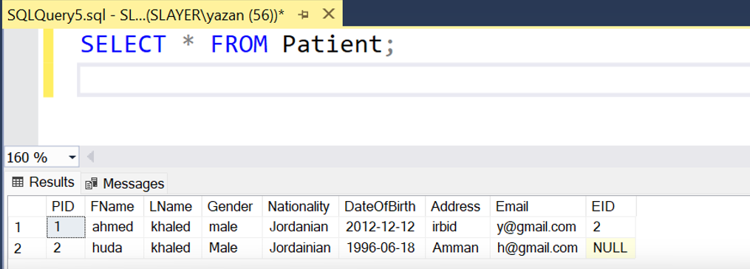

**Go away**

**The ability to book a facility for specific medical purposes.**



**Patients' ability to use and reserve specific equipment and access information about available medical equipment.**





**Ensure that personal data is secure and not accessible to unauthorized individuals**

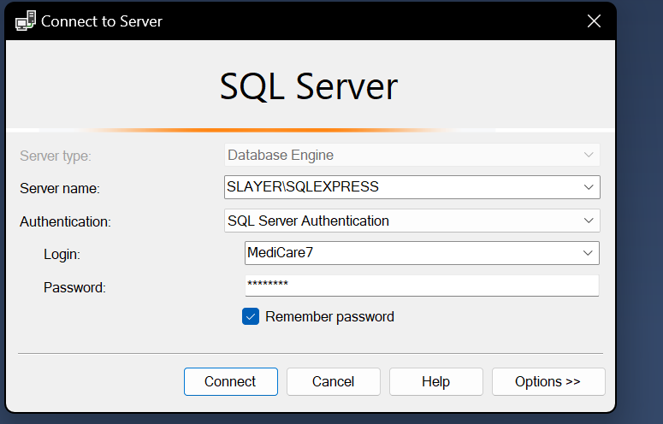

**Confirm data backups for reliability**

**System Requirements:**

**Secure login system with encrypted password storage**

**A centralized database to store patient information, doctor details, nurse and staff details, facility information, and equipment data.**

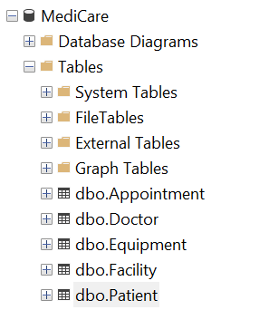

**Unique identifiers (IDs) for patients, doctors, facilities and equipment for efficient data retrieval**

**Validations to ensure data integrity for example, unique email constraint, mandatory fields.**

**Regular and automated data backup to prevent data loss in case of system failure or data corruption.**

**System logic to ensure that the default values of the nationality "Jordanian" are set when the necessary data is not provided**

|  |  |
| --- | --- |
| Requirements | Directory |
| 1- The possibility of registering patients for an account with unique identifiers (email, password) to access the system. | Focus on data security in the cloud-based hospital database system on the registration page. |
| 2- A secure login process that ensures confidentiality and data security. | Secure login system with encrypted password storage. Authorization protocols for access control based on user roles on the sign-in page. |
| 3- The ability to update and manage personal information (name, contact details, address, nationality, date of birth) of patients. | Having unique patient identifiers such as patient ID, name, contact details, gender, date of birth, address, and nationality on the registration page. |
| 4- View the information of the booked facility and the associated dates. | Patients can book one facility, share equipment among multiple patients, and allow each patient to use only a specific equipment on the services page. |
| 5. View the appointment date and upcoming schedules. | Include the doctor selection feature in the appointment booking interface to know important information. |
| 6- The ability to reserve a facility for specific medical purposes. | Patients can book one facility, share equipment among multiple patients, and allow each patient to use only a specific equipment on the services page. |
| 7- Prevent multiple facilities from being booked by the same patient at the same time. | Patients can book one facility, share equipment among multiple patients, and allow each patient to use only a specific equipment on the services page. |
| 8. Access to information about available medical equipment. | The presence of information about the equipment such as device ID, name, model and maintenance history in the database. |
| 9- The ability of patients to use and reserve specific equipment. | Patients can book one facility, share equipment among multiple patients, and allow each patient to use only a specific equipment on the services page. |
| 10. Ensure that personal data is secure and cannot be accessed by unauthorized individuals. | Secure login system with encrypted password storage. Delegation protocols to control access based on user roles. |
| 11- Confirm data backups for reliability. | Implement regular backup procedures to maintain data integrity and restore with AWS |
| 1. Secure login system with encrypted password storage. | Secure login system with encrypted password storage. Authorization protocols to control access based on user roles through AWS. |
| 2. Authorization protocols for access control based on user roles (patient, doctor, staff). | Secure login system with encrypted password storage. Delegation protocols to control access based on user roles. |
| 4. Unique identifiers (IDs) for patients, doctors, facilities and equipment for efficient data retrieval. | Unique identifiers for all attributes in the entities and the ERD schema. |
| 5. Validations to ensure data integrity (e.g., unique email constraint, mandatory fields). | Secure login system with password storage encrypted through AWS. |
| 6. A system to handle facility bookings by patients and allocate equipment for patient use. | Patients can book a single facility, share equipment among multiple patients, and allow each patient to use only a specific equipment from the services page. |
| 7. Regular and automated data backup to prevent data loss in case of system failure or data corruption. | Implement regular backup procedures to maintain data integrity and restore with AWS |
| 8- Implement data encryption methods to protect sensitive patient information. | Focus on data security in a cloud-based hospital database system with AWS |
| 9. Monitor and record the activities of the system for the purposes of security analysis and auditing. | Ensure robust network connectivity infrastructure to seamlessly handle day-to-day hospital operations with AWS |
| 10- System logic to ensure that the default values (Jordanian) are set when the necessary data is not provided. | Ensure robust network connectivity infrastructure to seamlessly handle day-to-day hospital operations with AWS |
| 11. Flexible network infrastructure to ensure smooth connectivity, especially during high load times. | Ensure robust network connectivity infrastructure to seamlessly handle day-to-day hospital operations with AWS |

**Recommendations for continuous improvement:**

**Enhanced data encryption standards:**

Consider adopting advanced encryption algorithms to further enhance data protection. Keep abreast of emerging encryption technologies to ensure that the latest security measures are implemented.

**Ongoing security audits and vulnerability assessments:**

Carry out regular security audits and vulnerability assessments to proactively identify and address potential vulnerabilities. Participate in continuous monitoring and testing to ensure the resilience of the security infrastructure.

**Advanced user authentication mechanisms:**

Explore the integration of advanced authentication mechanisms such as biometrics or multi-factor authentication (MFA) to add an additional layer of user identity verification. This enhances comprehensive access control and reduces the risk of unauthorized access.

**Blockchain implementation for data integrity:**

Assess the feasibility of integrating blockchain technology to ensure data integrity. Blockchain's decentralized and tamper-resistant nature can provide an extra layer of security and confidence in the safety of patient data.

**Detecting AI-based anomalies:**

Investigate the integration of artificial intelligence (AI) algorithms to detect anomalies within a database system. AI can help identify unusual patterns or behaviors, contributing to the early detection of potential security threats.

**User Training and Awareness Programs:**

Develop comprehensive training programs for system users to enhance awareness of cybersecurity best practices. Educate users about identifying and reporting potential security threats, and foster a culture of collective responsibility for data security.

**Perform data masking and redacting:**

Introduce data anonymization and redaction techniques to protect sensitive information. This ensures that even users with certain access privileges only see information relevant to their roles, reducing the risk of exposure to unauthorized data.

**Adoption of industry compliance standards:**

Evaluate the adoption of industry-specific compliance standards and certifications. This not only ensures compliance with regulatory requirements, but also demonstrates a commitment to maintaining the highest standards of data security and privacy.

**Integration of threat intelligence feeds:**

Consider integrating threat intelligence feeds to stay informed of emerging cybersecurity threats. Real-time threat intelligence can enable the system to quickly adapt to evolving security challenges, strengthening its defenses.

**Regular review and improvement of backup strategies:**

Review and optimize backup strategies periodically to match evolving data volumes and system complexities. Ensure fast data recovery in the event of unexpected incidents, and reduce downtime and data loss.

**Implementation of disaster recovery training:**

Conduct regular disaster recovery exercises to assess the efficiency and effectiveness of recovery actions. These simulation exercises help identify areas for improvement and ensure rapid response in real-world scenarios.

**Collaborate with cybersecurity experts:**

Strengthen collaboration with external cybersecurity experts to conduct independent assessments and recommendations. Interact with healthcare IT security professionals to leverage their expertise in protecting patient data.

**Expansion of Security Information Systems and Event Management (SIEM):**

Extend the capabilities of security information and event management systems (SIEM) to provide real-time analysis of security alerts. This proactive approach enables the rapid identification and mitigation of potential security incidents.

**Implement a Zero Trust security model:**

Explore the adoption of the Zero Trust security model, which assumes that there is no implicit trust within the system. This model requires continuous verification of user identities and scans every access attempt, providing an additional layer of security.

**Regular training of employees on cybersecurity threats:**

Ensure that employees receive continuous training on the latest cybersecurity threats and tactics. Building an attentive and informed workforce is critical in preventing social engineering attacks and maintaining a strong security posture.

**Integrating these recommendations into the existing cloud database system will contribute to its continuous enhancement, security and sustainable protection of patient data. Regular reviews, proactive measures, and strategic investments in cybersecurity technologies will collectively enhance the resilience of healthcare database infrastructure.**

At the end of your work, you should think and evaluate trades created in your cloud database, in terms of access times, data security, and cost-effectiveness. In addition, discuss and present improvements and suggestions that will be implemented to ensure the system's suitability for the future.

**Reflection and evaluation in cloud database implementation:**

Implementing a cloud database in a healthcare system brings transformative benefits along with challenges that require thoughtful consideration. In assessing the implications, three important aspects – latency, data security, and costability – emerge as focal points for assessment.

**Arrival Times:**

**Positive effects:**

The cloud database facilitates quick and remote access to patient information, enhancing the efficiency of healthcare delivery.

Scalability features ensure the system is able to accommodate increased demand during peak times, preventing access delays.

Automated load balancing mechanisms improve response times and improve the user experience for both healthcare professionals and patients.

**Challenges:**

Location and internet connectivity can affect access times, especially in remote areas or areas with inconsistent connectivity.

Relying on external service providers results in dependencies that may affect access times during service or maintenance outages.

**Improvements and suggestions:**

Implement content delivery networks (CDNs) to cache frequently accessed data and deliver it closer to end users, reducing latency.

Use redundant data centers in geographically diverse locations to ensure continuous access even during regional service outages.

**Data Security:**

**Positive effects:**

Cloud providers often implement robust security measures, including encryption, access controls, and regular security audits.

Centralized security management simplifies the process of implementing data protection policies across the entire database infrastructure.

Constant updates and patches from your cloud service provider enhance protection against emerging security threats.

**Challenges:**

Concerns may arise about data sovereignty and compliance, especially when handling sensitive healthcare information subject to specific regulations.

The shared responsibility model requires a clear delineation of responsibilities between the healthcare organization and the cloud service provider to avoid security vulnerabilities.

**Improvements and suggestions:**

Implement data encryption at rest and in transit to enhance data security and compliance.

Establish a comprehensive data management framework to ensure compliance with regulatory requirements and maintain control over patient data.

**Feasibility in terms of cost:**

**Positive effects:**

Cloud databases often run on a pay-as-you-go model, providing scalability without the need for large upfront investments.

The cost efficiency of cloud solutions can be attributed to resource optimization, automated maintenance, and shared infrastructure.

**Challenges:**

Using unattended resources or misconfigurations can lead to unexpected costs, necessitating vigilant cost management.

The long-term costs of subscription-based models should be assessed against potential initial investments in local solutions.

**Improvements and suggestions:**

Implement and optimize cost control tools to track resource usage and identify potential areas for cost savings.

Perform regular cost-benefit analyses to assess the financial implications of maintaining a cloud database versus alternative solutions.

**Data backup and disaster recovery:**

Cloud databases typically provide built-in mechanisms for backup and disaster recovery. Regular data backup and restoration testing is essential to ensure data integrity and availability.

Consider the costs associated with data backup and disaster recovery, including storage fees and potential data transfer costs in the event of recovery from a different region or provider.

Evaluate the requirements of the recovery time goal (RTO) and recovery point goal (RPO) of the database system to determine the appropriate backup and recovery strategy.

**General recommendations on the suitability of the continuous system:**

**Continuous performance monitoring:** Monitor the performance of the cloud database system regularly to identify any bottlenecks or issues that may affect access times. Use monitoring tools and performance metrics to track database performance, query execution times, and resource usage. This will help identify areas for improvement and ensure a smooth user experience.

**Scalability planning**: As the user base and data volume grow, it's important to plan for scalability. Evaluate the current system architecture and consider implementing horizontal scaling by distributing database load across multiple instances or using segmentation techniques. This will ensure that the system is able to handle increased demands without compromising performance

**Disaster recovery and backup strategy**: Review your existing disaster recovery and backup strategy to ensure data integrity and availability. Perform automated backups at regular intervals and test the restore process to make sure the data can be recovered successfully.

**Comprehensive Training Programs:**

Conduct regular training programs for employees to ensure optimal use of cloud-based features and adherence to security protocols.

**Incident Response Planning:** Develop and regularly update incident response plans to address potential disruptions, ensuring rapid recovery and minimal downtime.

**Regular security audits:** Conduct regular security audits to identify potential vulnerabilities and ensure compliance with industry standards and regulations. Perform penetration testing and vulnerability assessment to identify any vulnerabilities in the system. Stay up-to-date with security best practices and apply patches and updates promptly to mitigate security risks.

**Scalability planning**: As the user base and data volume grow, it's important to plan for scalability. Evaluate the current system architecture and consider implementing horizontal scaling by distributing database load across multiple instances or using segmentation techniques. This will ensure that the system is able to handle increased demands without compromising performance

**Regular system updates and patch management:** Stay up to date with the latest patches, updates, and security fixes offered by your cloud service provider. Establish a patch management process to ensure timely updates are applied to address any vulnerabilities or performance improvements.

**User feedback and continuous improvement**: Gather feedback from users and stakeholders to identify areas for improvement. Implement a feedback mechanism or user surveys to gather ideas and suggestions to improve the user experience and system functionality. Review and prioritize user feedback regularly to drive continuous improvement of the cloud database system.

**Cost optimization:** Continuously monitor and optimize costs associated with a cloud database system. Review usage patterns and resource allocation to identify cost-saving opportunities. Consider using Reserved Instances or Spot Instances for predictable workloads and leverage automatic scaling to dynamically adjust resources on demand. Effectively implement and track resource tags to identify cost centers and optimize resource allocation.

**Collaboration with your cloud service provider:**

Foster a collaborative relationship with your cloud service provider, and participate in regular discussions to explore new features, updates, and improvements.

**Data encryption:** Enhance data security by applying encryption technologies at rest and in transit. Use encryption mechanisms provided by your cloud service provider or implement additional encryption layers within the application to protect sensitive data. This ensures that even if unauthorized access occurs, the data remains secure.

**Community Engagement:**

Engage healthcare professionals, patients, and stakeholders in the decision-making process, ensuring that the cloud database system aligns with their evolving needs and expectations.

**In conclusion, the successful implementation of the cloud database in the healthcare sector requires a thorough assessment of its impacts on access times, data security, and cost cost. Continuous improvement strategies, which include technological advancements and alignment with regulatory requirements, will ensure the continued suitability and success of a cloud-based healthcare database system. This commitment to excellence in system management and enhancement will contribute to improving patient care, streamlining operations, and the overall success of the healthcare organization.**